**CS604 Assignment #1 spring 2023**

Name: Abdul Rehman.

VU-ID: BC220424444.

**Questions No 01 15 marks**

You are required to create the C program for Inter-process Communication between the parent and child process. Following are the functionalities to be carried out by your C program.

**Solution:**

* **C Code:**

#include <stdio.h>

#include <stdlib.h>

#include <unistd.h>

int main() {

int pipefd[2]; // file descriptor array for pipe

pid_t child_pid;

pid_t parent_pid = getpid(); // process id

if (pipe(pipefd) == -1) { // create pipe, check for errors

perror("Pipe creation failed");

return 1;

}

child_pid = fork(); // create child process

if (child_pid == -1) {

perror("Fork failed");

return 1;

}

if (child_pid == 0) { // Child process

pid_t child_process_id = getpid();

close(pipefd[0]); // Close unused read end of the pipe

write(pipefd[1], &child_process_id, sizeof(child_process_id)); // Write child process ID to pipe

close(pipefd[1]); // Close the write end of pipe

return 0;

} else { // Parent process

pid_t child_process_id;

close(pipefd[1]); // Close unused write end of pipe

read(pipefd[0], &child_process_id, sizeof(child_process_id)); // Read child process ID from pipe

close(pipefd[0]); // Close the read end of pipe

printf("parent (pid:%d): Received child process ID %d\n", parent_pid, child_process_id);

printf("parent (pid:%d): Parent process ID is %d\n", parent_pid, parent_pid);

return 0;

}

}

* **Output Screenshot:**

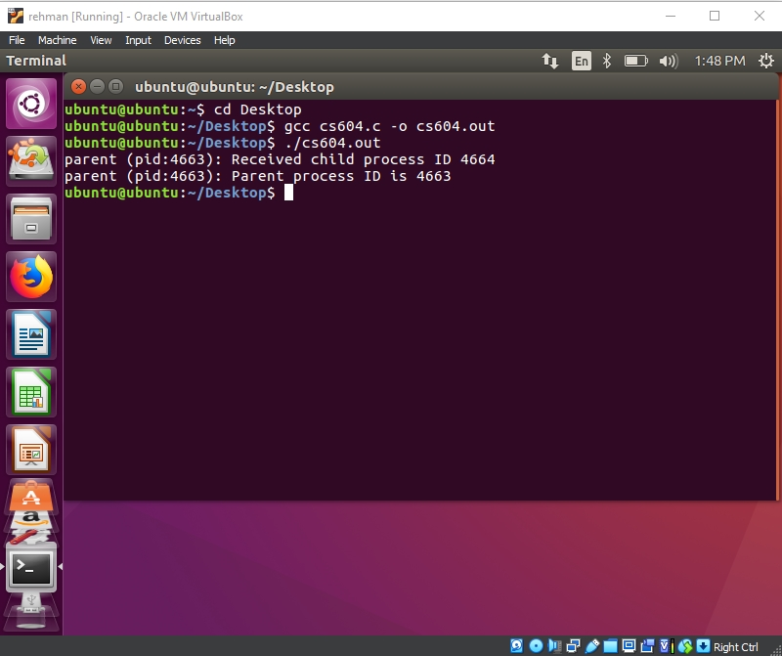

**Questions No 02 5 marks**

In the following table write the Linux command for the given details.

**Solution:**

|  |  |
| --- | --- |
| **Detail.** | **Linux Command** |
| Command to list the contents of current working directory. | ls |
| Command to change the current working directory. | cd directory_name |
| Command used to search for a pattern in a file or files. | grep pattern file(s) |
| Command is used to display the contents of a file. It can also be used to display the entire contents of a file or a portion of the contents, depending on the options used. | cat file_name  or  cat -n file_name |
| Command is used to remove a file or directory. | rm file_name  or  rm -r directory_name |

* **Output Screenshot:**

